Kaunas University of Technology
Faculty of Electric and Electronic Engineering
Arduino Project Report

Student Name, Surname:
Farhana Khanom Fariha

18th December, 2025

Table of Contents
Introduction 3
Applications of the Robot 3
Technical Analysis of Arm Robot 3
Working principles 4
Components and Their Description 4
Block diagram: 5
Circuit Diagram: 5
My Arduino Arm Robot Prototype: 6
IDE Code 7

Project Overview
This project focuses on developing an arm robot using Arduino UNO, servo motors, and the hardware components. The robot can mimic human activities like picking and placing objects. It can move its arm back and forth, forearm up and down and rotate about the base in 90 degrees angle.

Purpose:
To design, control, and test a robotic arm capable of picking and placing small objects using Arduino microcontroller.

Introduction
An Arduino Robot Arm is a programmable mechanical device that can work like a human arm. Robot arms are used in automation, manufacturing, aviation, research laboratories and medical science. This device consists of multiple joints, kinematic pairs, motors and links that connect parts of the robot. These parameters help a robot to perform tasks like lifting, rotating and gripping objects. In this project, I have designed an Arduino based robotic arm to pick and place small objects. This robot consists of 4 servo motors connected through the mechanical links namely, base, shoulder, elbow and gripper providing 4 Degrees of Freedom (DoFs).
The main objectives of this project are:
- To design a robotic arm with 6 links
- To analyse its kinematic structure and calculate degrees of freedom
- To create a prototype of the robot
- To evaluate the robot’s working principle, technical characteristics, and workspace.

Applications of the Robot

* Picking and lifting the objects
* Moving objects in space
* Place the objects in correct positions
* Moving foreward and backward
* Moving up and down
* Rotating 90 degrees from right to left and left to right

Technical Analysis of Arm Robot

The main technical characteristics of the designed Arduino-based robotic arm are:
- Type of robot: Planar robotic arm with closed-chain (parallelogram) mechanism
- Control unit: Arduino microcontroller
- Actuators: Servo motors (base, shoulder, arm, gripper)
- End effector: Two-finger gripper
- Operating motion: Pick-and-place operations of small objects
- Power supply: Low-voltage DC supply

Working principles
The robot has four servo motors, and the base servo motor helps the robot to rotate from right to left and from left to right in horizontal axis. The motos connected to the shoulders and arms have rotational motion and thus help the shoulders move back and forth and the arms up and down in the vertical plane. The fourth servo is connected to the gripper and helps the end effector to open and close. Thus, the gripper can pick object and release it in the correct place. The arm section of the robot includes a parallelogram four-bar linkage that forms a closed kinematic chain. By combining the motion of the servo motors, the robot can lift, move, and place small objects accurately.

Components and Their Description

Hardware
Arduino UNO: The Uno is one of the most popular Arduino boards. It consists of 14-digital I/O pins, where 6-pins can be used as PWM (pulse width modulation outputs), 6-analog inputs, a reset button, a power jack and a USB connection.
Servo Motor: A servomotor is a rotary actuator or linear actuator. It can precisely control angular or linear position, velocity and acceleration. It also requires a relatively sophisticated controller, often a dedicated module designed speciﬁcally for use with servomotors. In this project, four servo motors with rotational motion have been used.

Software
Arduino IDE: It is a platform for writing and uploading program code to the Arduino. After running the code on Arduino IDE, the robot's motor start to work in a loop motion.

Block diagram:

PC Arduino Servo Motors

Circuit Diagram:
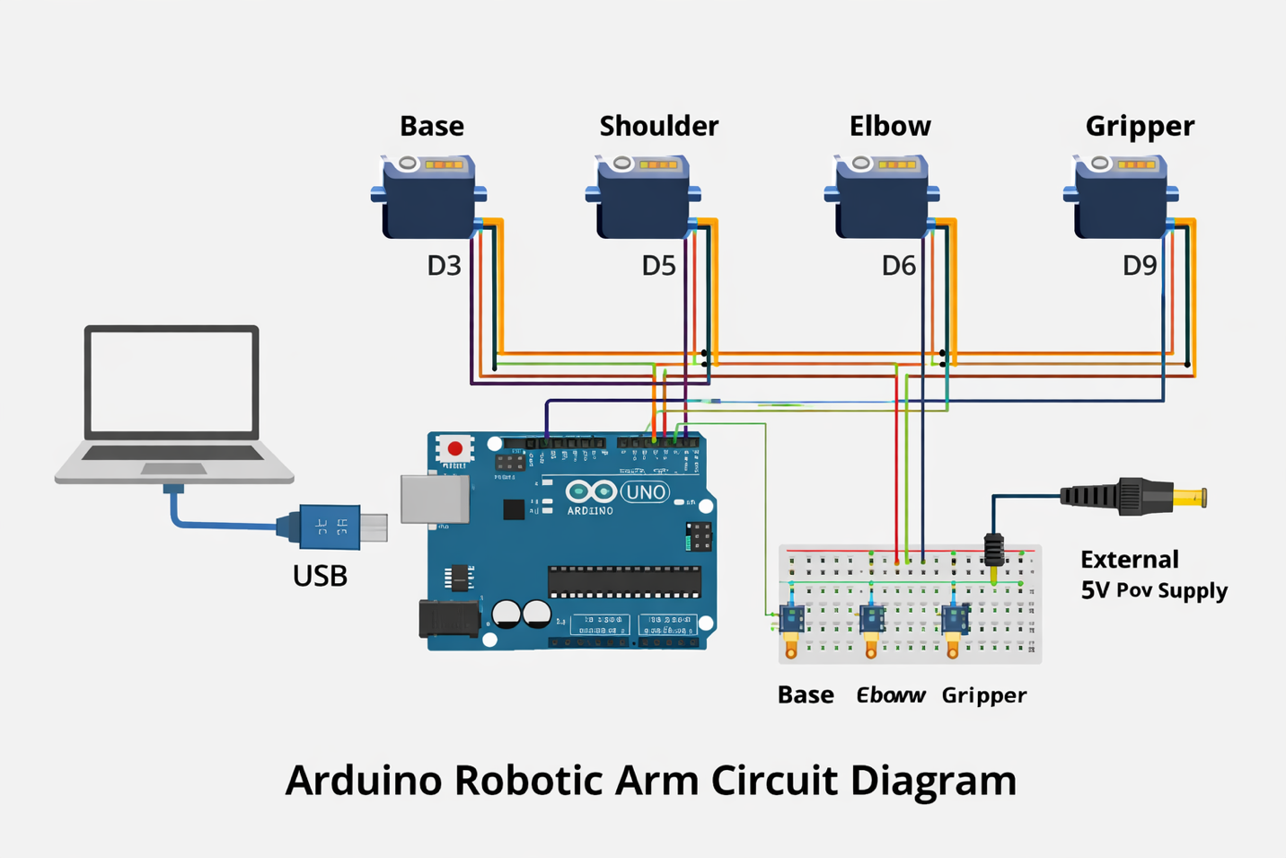

My Arduino Arm Robot Prototype:
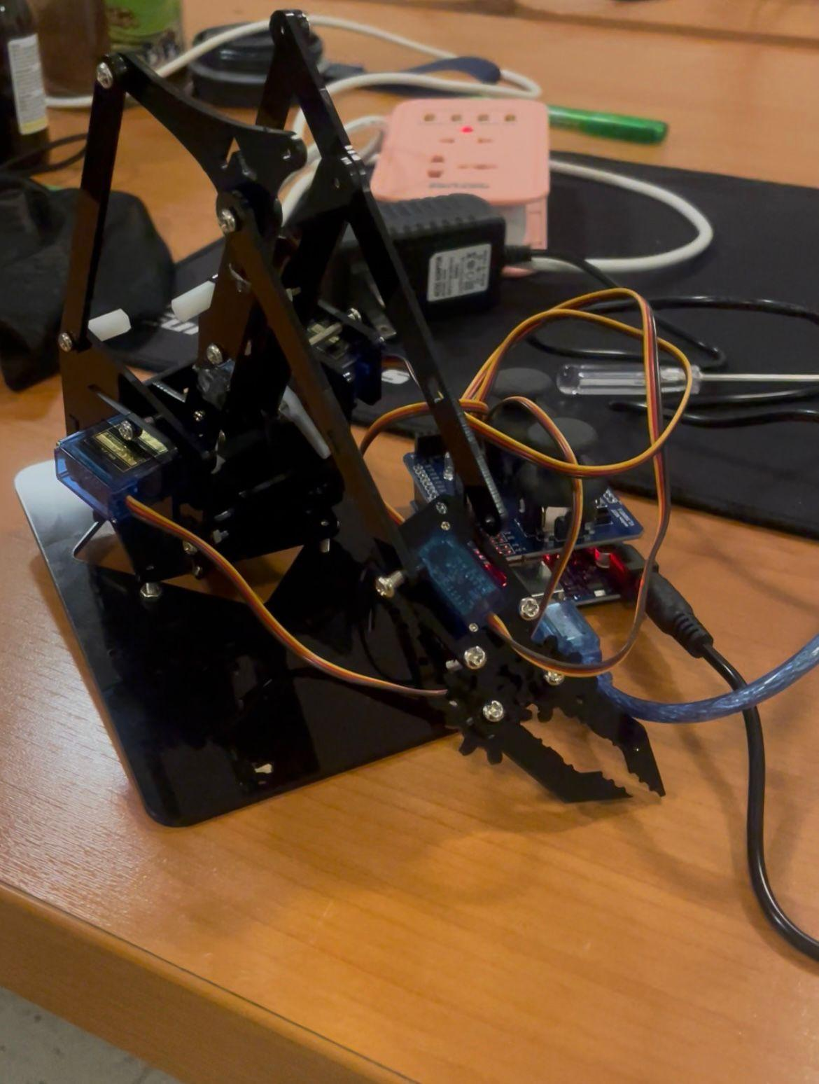

IDE Code

#include <Servo.h>

Servo servo1; // Base
Servo servo2; // Shoulder
Servo servo3; // Elbow
Servo servo4; // Gripper

void setup() {
servo1.attach(6); // Base
servo2.attach(7); // Shoulder
servo3.attach(9); // Elbow
servo4.attach(10); // Gripper
}

void loop() {
// Example motion
servo1.write(90); // Base center
servo2.write(45); // Shoulder up
servo3.write(120); // Elbow bent
servo4.write(0); // Gripper open
delay(1000);
}

